DETECTION AND ALERTING OF UNAUTHORIZED SSH LOGIN ATTEMPTS USING SPLUNK

NAME: D. SHOBIJA
COURSE: ADCD

Step 1: Connect ssh in the kali:

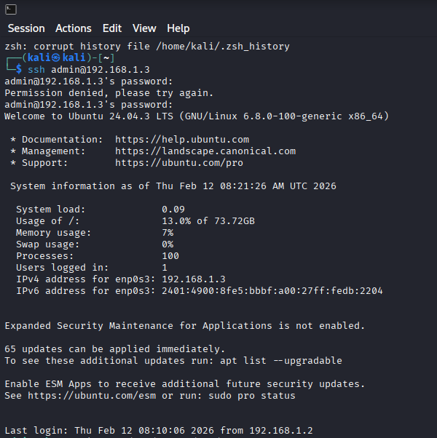

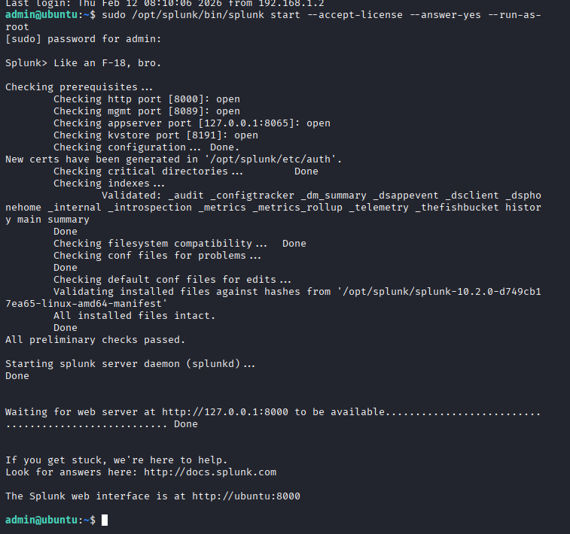
If you give wrong password here that was fine. it’s used for after some time.

Step 2: login Splunk:
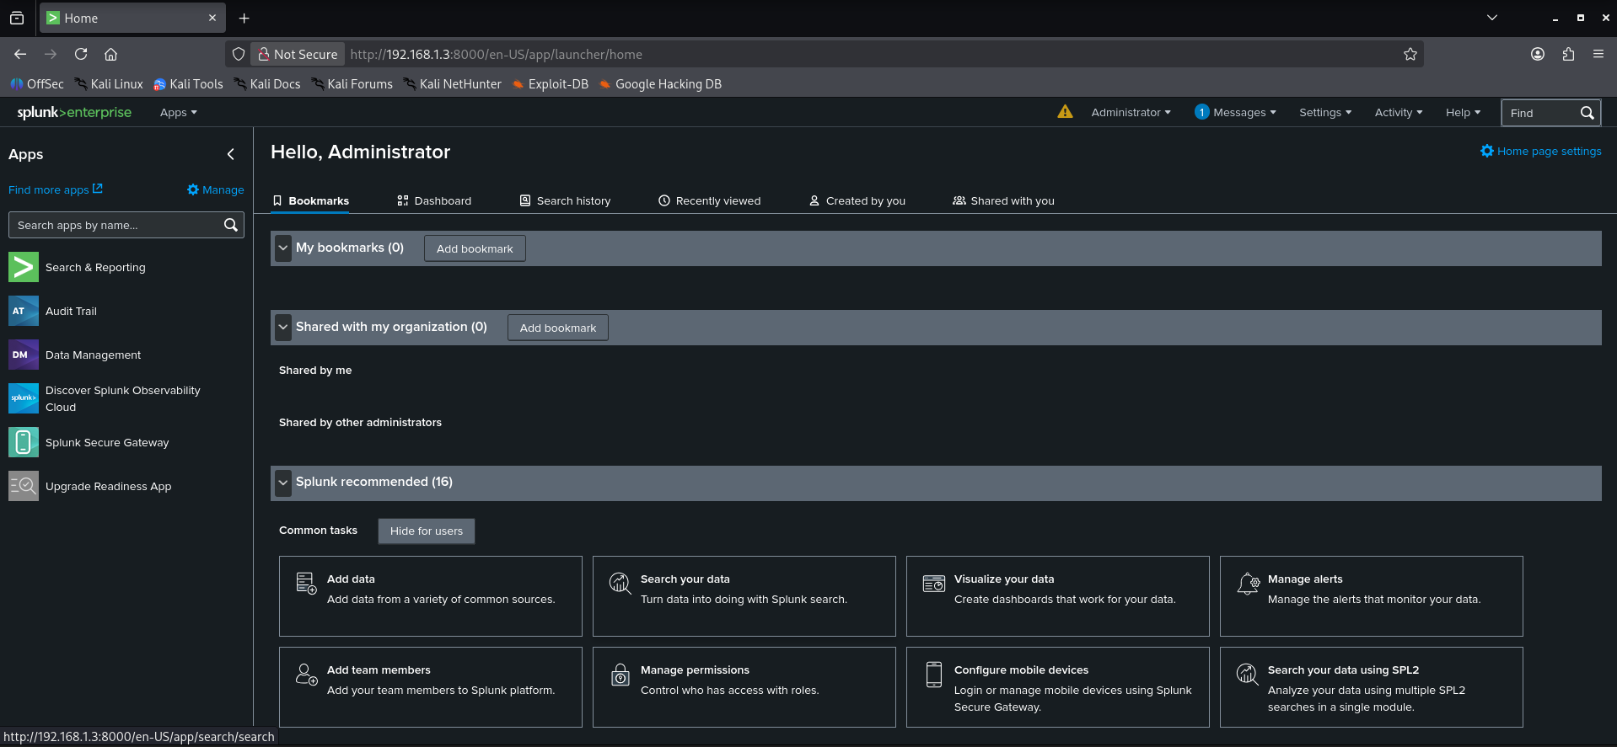
We need to login Splunk. It’s opened above mentioned page.

Step 3: Make Sure Ubuntu SSH Logs Are Ingested into Splunk:
- Go to settings Click Add Data
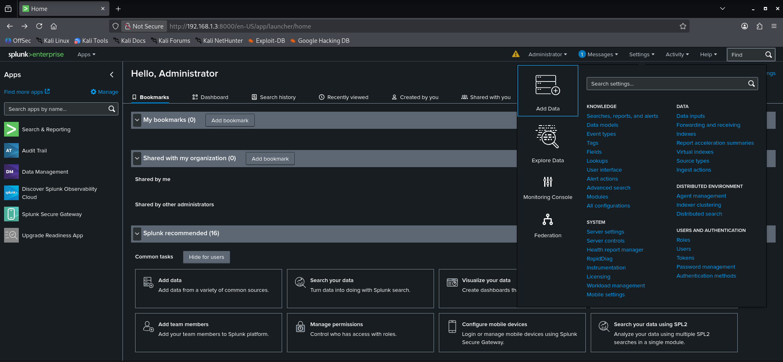

- A page will open as shown below

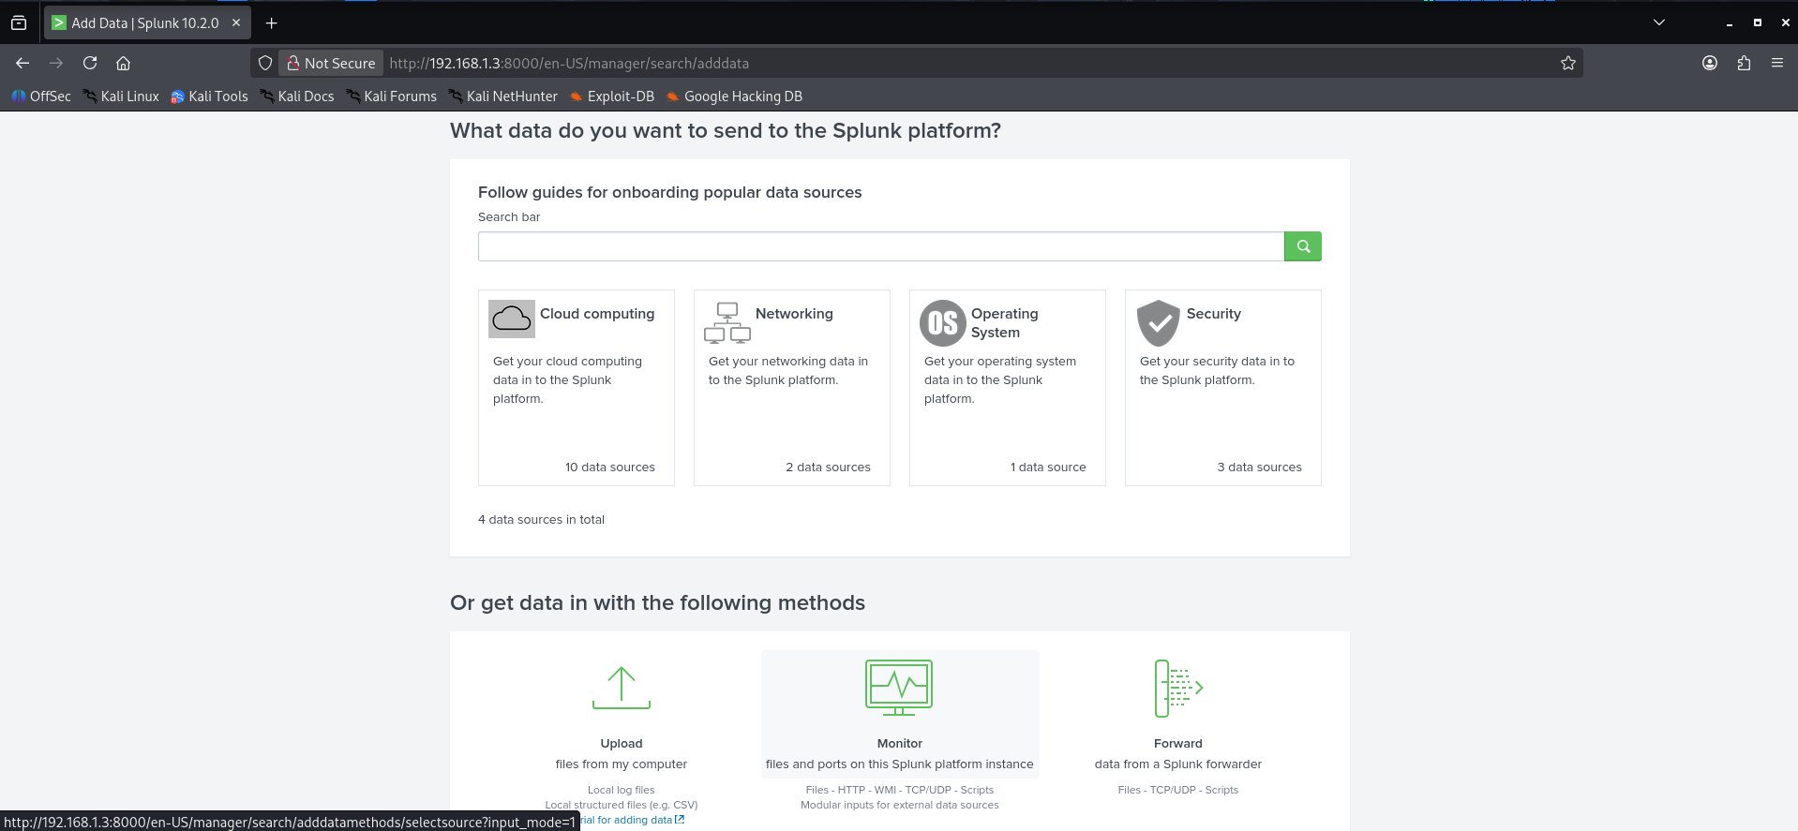

- Click Monitor Files & Directories
File or Directory: /var/log/auth.log Next

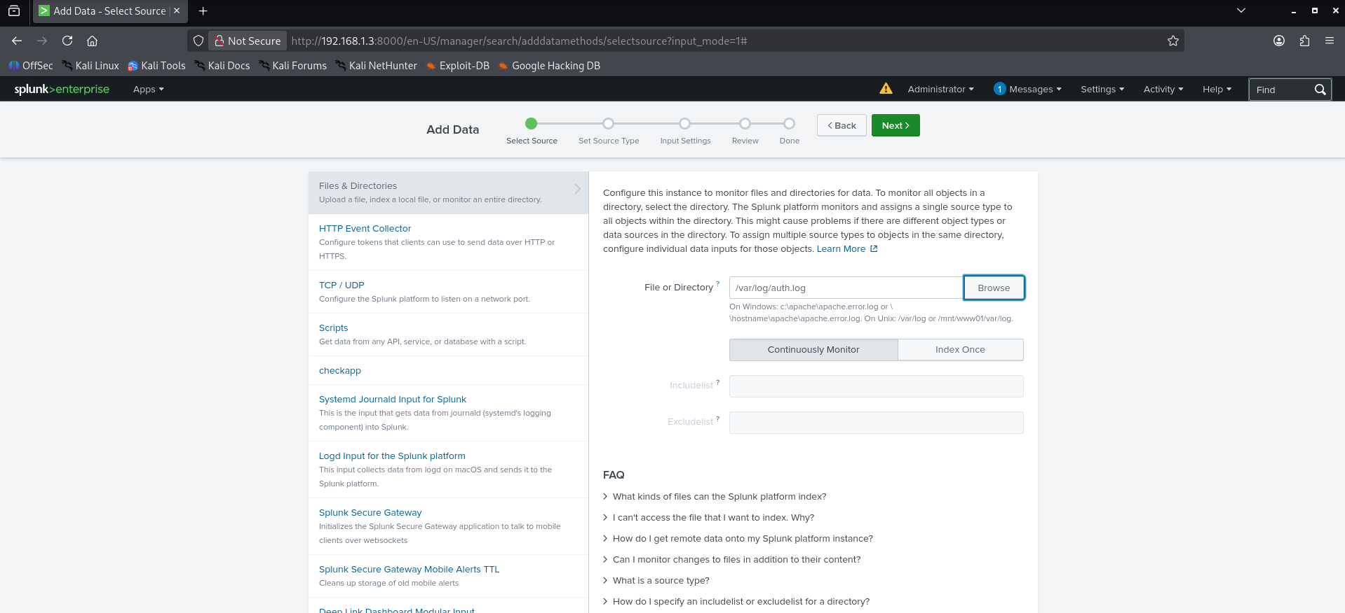
- Change Source Type : Operating System Linux Secure Next
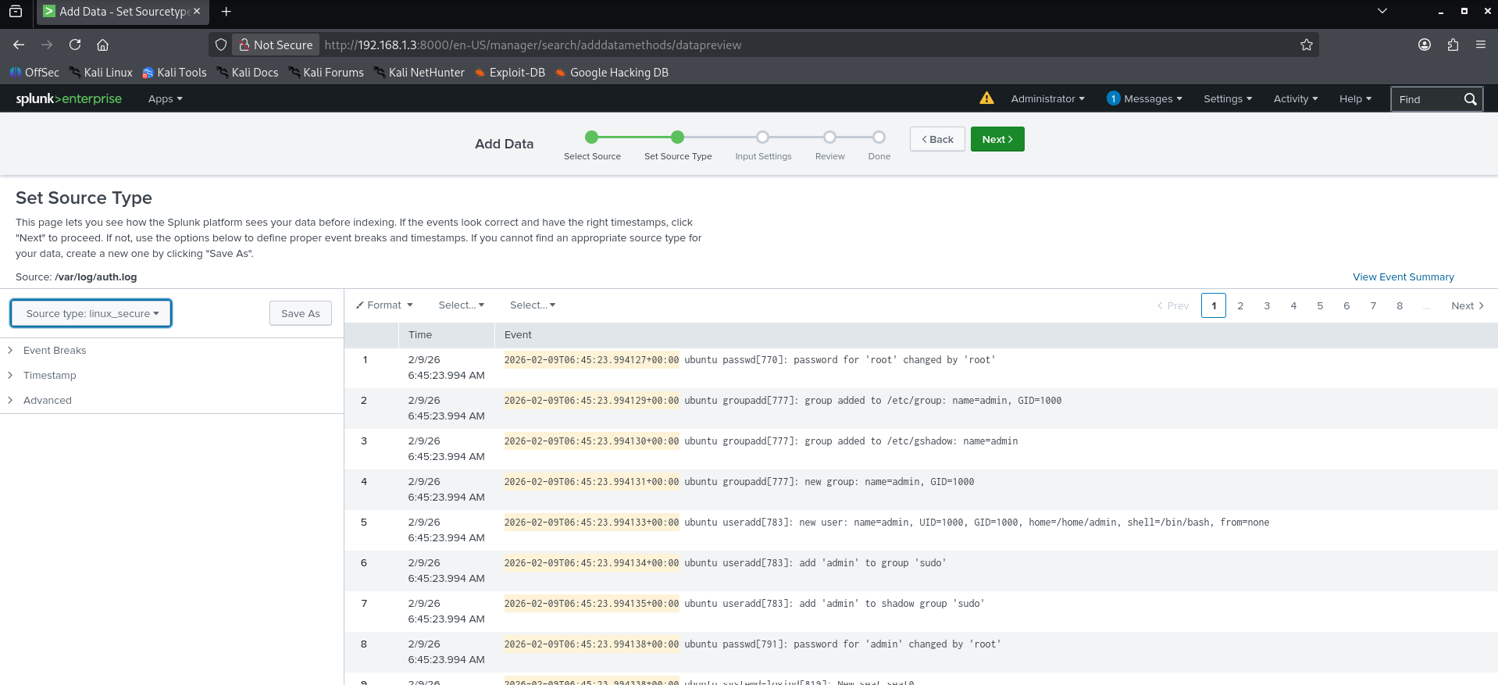

- Click review

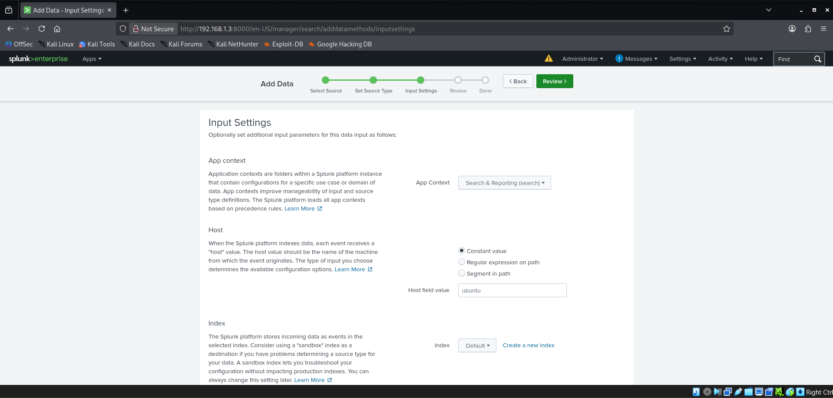
- Click submit

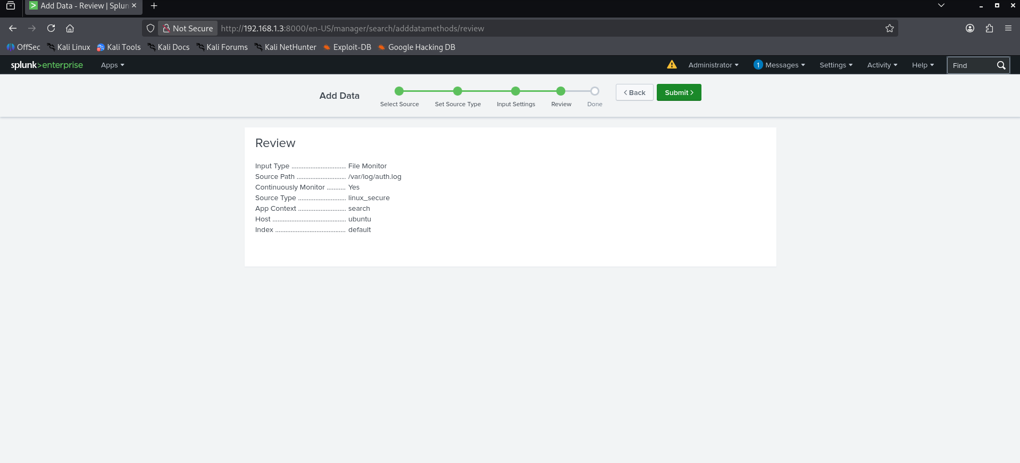

- Click Start searching

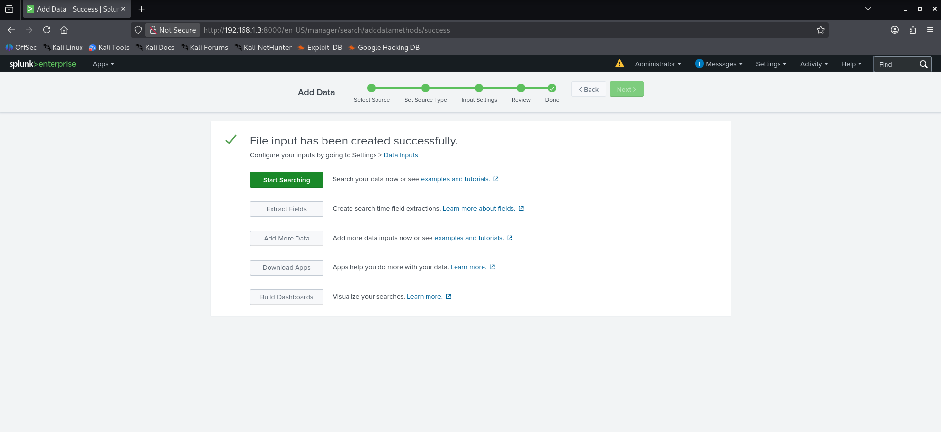
- A page will open as shown below

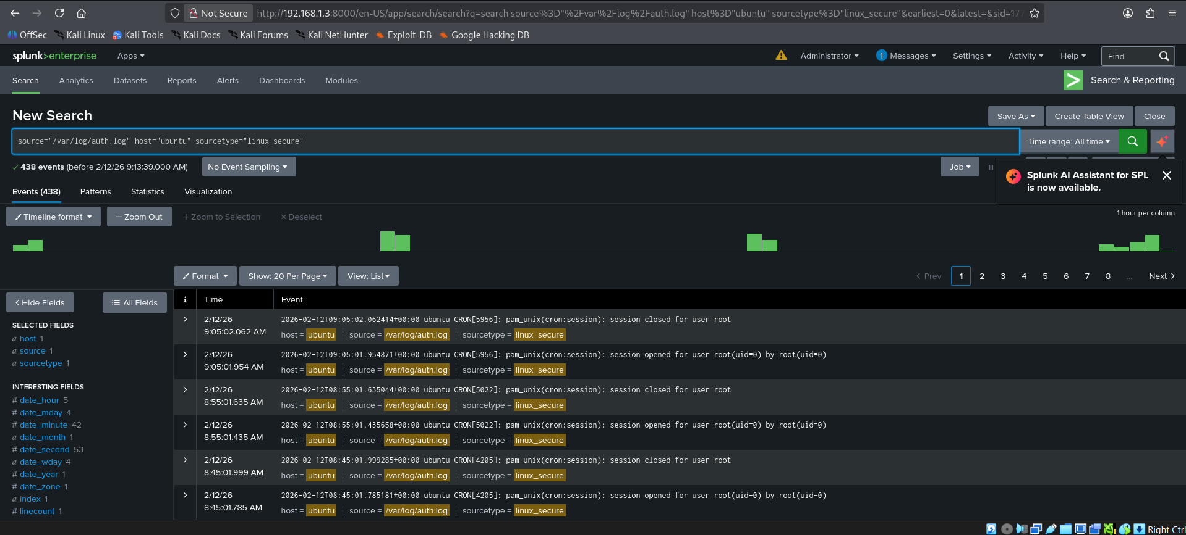
- Search for Failed SSH Login Attempts:
Go to New search Type source="/var/log/auth.log" "Failed password" Search
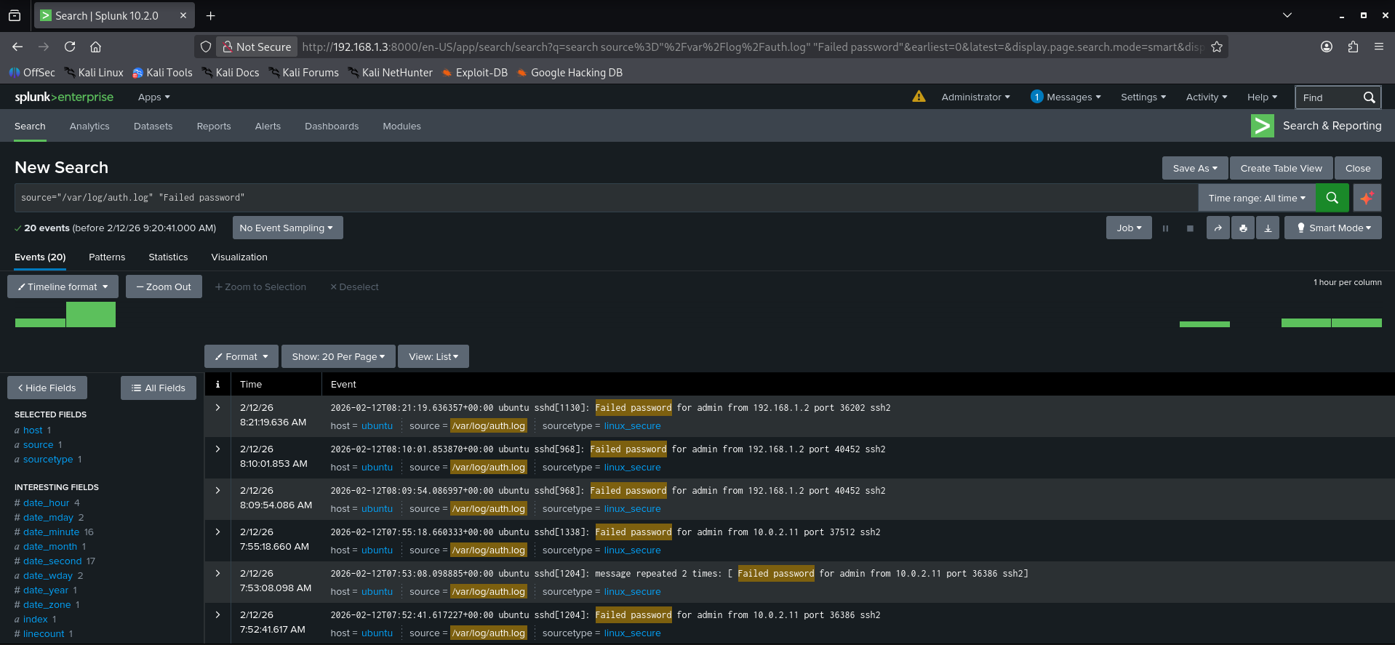
If you search for the term ‘Failed password’ in Splunk, it will display all recorded events where incorrect password attempts were made.
Step 4: Failed log Alert Settings:
- Click Save as Alert
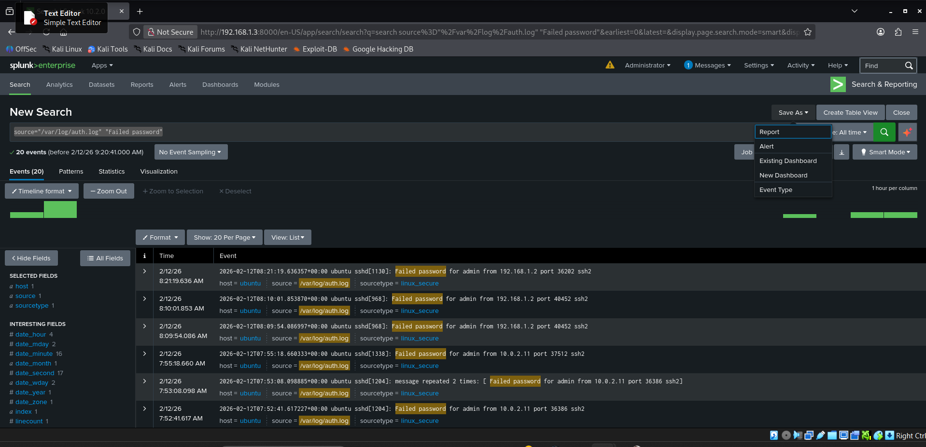
- Set Alert Actions
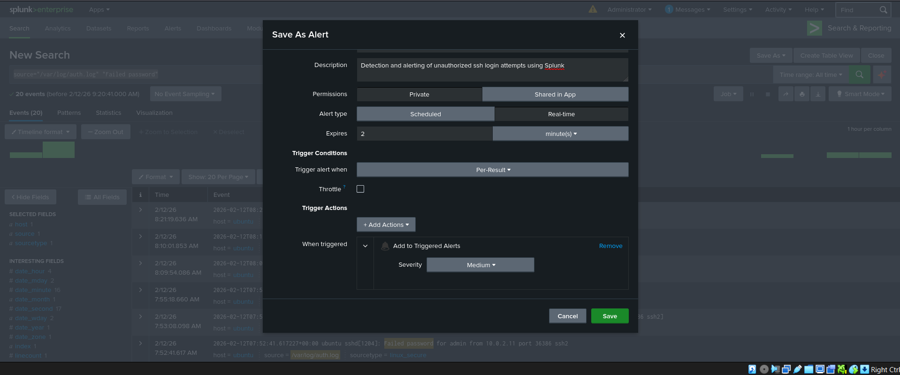
Title : Failed log Attempt
Description : Detection and alerting of unauthorized ssh login attempts
using Splunk
Alert type : Real time
Expires : 2 minutes
Trigger Actions : Add actions Select Add to Triggered Alerts
Severity: Medium Save
- A pop-up show

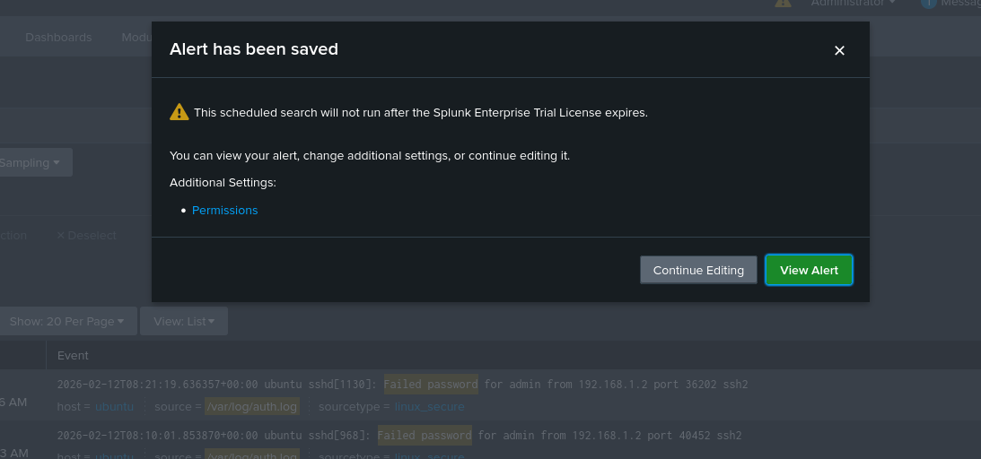
- Alert has been saved View Alert

- Failed log Attempt

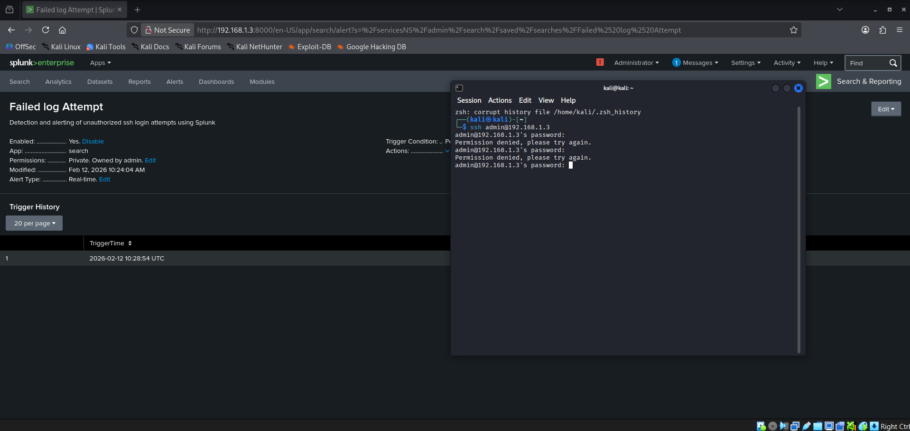
If you are trying to log in with the wrong password in the ssh, it’s shows alert in the Splunk alert page.
- Track unauthorized SSH access attempts

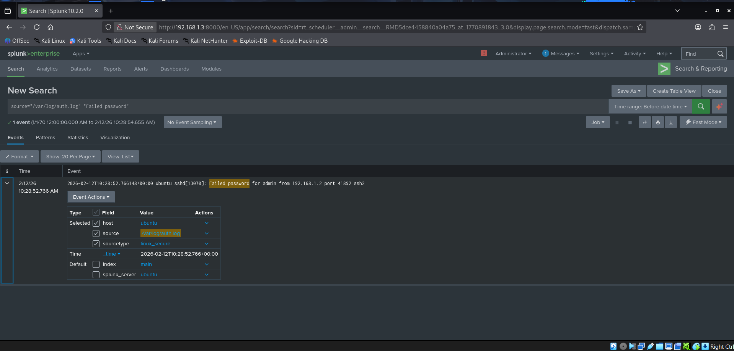
Click View Results

Conclusion:

By setting up this failed login alert, an immediate notification will be generated whenever an unknown person attempts to log in. This allows us to quickly identify the attacker’s details and take prompt action to prevent unauthorized access.

